Expert system to simulate human mind for automatic Planning
of preparing period in handball

*Ahmed Mohammed El-kot
Abstract:
This research aim is to establish a system using one of the artificial intelligence applications for planning preparing period Guided by technical and physical measurements in handball, researcher used two approaches descriptive and experimental, research sample consisted of 11 players within the club team Benha Sports, The researcher analyzed the documents and references, and use different programming languages to create a system , the most important results was the validity and reliability and objectivity of the system in the output of the results from which you can get the standard grades of technical and physical measurements And identify training amount for each period separately and control the degree of load and the times of different modules physical load rates and the contribution of physical attributes for the development of various skills through training modules.
Key words: Expert system –Simulate –Planning –preparing Period –Handball.
Introduction
Planning has a big role in the athletic training process and it is the only way to elevate a level of performance in all sports in general and Handball especially to the best sports team levels. If we look at the sports training, we find that those in charge of the training process is also seeking access to this development in order to take advantage of it and be subjected to the process of training to get the player to the highest levels of sports through the exploitation of science and scientific progress and the placement of this science[1].It is noteworthy "that sports training is the main part in the sports setting process as a basic process for the development of physical skills and qualities necessary for the athlete to achieve the highest possible level of activity in the practitioner[2].A lot of developed countries made continuous efforts in handball to prepare and develop handball players teams for juniors on clear scientific basis as a basic rule petition that depend on them for the growth and prosperity of the game, here it appears important to the planning process for the construction of the training programs role[3].The modern training in handball and planned well in accordance with the principles of scientific principles plays an important role in the preparation of the player in an integrated and essential manner access to sports models which means higher level of physical , Skill ,psychological and Physiology at the end of the preparation period and maintained during the period of the competition so that it can get the best results[4].Interest has been growing about the development of software programs can done with computers and the tasks can be described as intelligent, but the fact is that planning has become of the actual operations that are related to the human knowledge that depend on various scientific rules and laws largely[5].Most experts agreed that the concept of artificial intelligence is limited in that one study areas mainly concerned with the design and programming of computers to achieve the tasks and business needs of people usually use their intelligence to do[6].
Artificial intelligence cares about creation of software components and materials capable of simulating human behavior and is known as the computers as ability to simulate some of the capabilities of the human mind and make some simple decisions and other simple[7].The expert system is one of the science of artificial intelligence applications, which is considered one of modern science in the field of computers, which is one of the largest and widest fields of application of Computer Science[6].The expert system is a computer system that includes a broad base of knowledge made up of several facts about a particular field and the rules of research determines how to take advantage of these facts and contains all of the queries that can be touched on the mind of the coach, also contains specific answers to these Inquiries[8].And participate in the construction of an expert system a group of elements which include domain expert and knowledge engineer and system building tool and expert system itself and the user expert system and the crew enter data and information to the expert system[9].Building expert systems Called knowledge engineering process name and usually include a special form of dialogue between the expert in charge of the system called knowledge engineer's name, and one or more of the experts in one of the areas which will be presented expert system to solve problems[10].And highlights the importance of using an expert system in sports training ,it can assemble and identify knowledge resulting from human experience in the field of athletic training and sports physiology and planning in general and preservation of leakage or loss, as it highlights the importance of the advantage in time-saving element in planning operations and performance more accurately, which is difficult to achieve human potential[11].It is the general problems in the field of athletic training is the lack of planning as it is considered an obstacle to the development of the sport sciences, not only in Egypt, but extends to other countries of the world[12].the difficulty of the training process shown from the beginning of training dose planning and even multi-year courses, they often cause errors in the initial periods of preparation stops level of the player in coming period Therefore, the planning of the athletic training is not easy due to the complexity of the training process elements[13].On the other hand, researchers in the field of training propose training programs placed on some of the general planning of training and often neglect to put pre- measurement into account during the planning results for the period of preparation. The researcher suggests that the foundations of the training program is to develop an appropriate program content to capabilities of research sample, how to take into account the level of pre- measurement of the team to legalize the times of the training program .The researcher also indicates that the vast majority of coaches neglect After measurement, which occurs before the planning work for standard grades of the results of the tests and thus the process of getting what is known as a percentage of the average variable, whether physical or skillful This is known as statistically class standard (T), which shows the extent of the players high and low in all measured parameters, which can be taken into account during the planning period to prepare for the development of physical attributes and performance skill and tactical players .Some trainers also neglect the development of the contribution of physical attributes that participate in handball skills ratios separately into account when planning training modules for the development of various skills during your preparation private period.
Corresponding Author: Ahmed Mohammed El-kot, Lecturer in Faculty of Physical Education, Benha University, Egypt. www.Bu.edu.eg

The study problem can be formulated in the possibility to answer the following questions:
- Can you set up an expert system which can be used in the application of the foundations of planning for the athletic training in handball?
- Can you supply expert system knowledge (information and ideas) to plan training?
- Can you get by using an expert system standard scores (T) to get to a certain level of team effectiveness measurement before the planning process is used by the trainer during the use of the system in the planning?
- Is it possible for an expert system taking into account the contribution of physical attributes for the development of skill performance ratios during the setup period?
- Is it possible for an expert system to put in mind the degree and course load and calculate the times of weeks, and training modules based on the degree of the maximum load, higher and average?
- Is it possible for an expert system to put in account the differing rates and times from both the public and private physical preparation, tactical and skill preparation during each period of preparation, whether (public preparation – private preparing - Pre-games)?
- Is it possible for the expert system to develop the training aim of the training module in mind during planning process?
Which the researcher is trying to keep up with the recruitment and use of modern technology to serve the training in the field of sports as we see in other countries
Aim of the research: -
This research aims to establish an expert system based on a knowledge using one of the applications of artificial intelligence as a mean of planning the preparing period guided by technical and physical measurements in handball
Impose of the research: -
Can create expert system based on knowledge codified and elaborate system and helps in substantive planning process of preparation period for handball players.

Research procedures:
Research Methodology:
The researcher used the descriptive approach, following the style survey and experimental approach when creating the system.
The research sample:
The research sample was selected intentionally from (11) players within Benha Sports Club team.
Means and tools of data collection:
Computer
To be used in the creation of an expert system using a variety of programming languages to setup on your computer.
Analysis of documents and references:
- The researcher analyzed the documents and references various previous studies in the field of handball, in order to identify both the physical attributes Special handball players and the most contribution to the level of performance skills and become acquainted with the skill and tactical performance variables in handball So that the researcher inventory of these variables and put them within planning the preparation period.
- The researcher analyzed the documents and references various previous studies so as to limit the tests used to measure both the selected physical attributes and performance skill of the handball players And that the inclusion of these tests within the expert system to conduct pre- measurement and obtain standardized degrees (T) and the level of the team, even guided by the coach in the planning.
- The following table shows the percentage of the contribution of physical attributes in some skill performance variables, quoting Mohammed Abd Allah Mohammed (2013) [4], which contributes to the link between physical attributes and skill ratios link which expert system modules during plan The situation in mind these qualities associating percentage at various skill performance variables development.
Table (1)
The contribution of the physical attributes of the variables performance
no | Physical attributes  Skills | Muscle power | Transition Speed | Distinctive strengths of legs | Distinctive strengths of arms | Flexibility | Strength endurance | Agility | Speed endurance | Accuracy | Compatibility | Performance speed | The speed of response | Total
1 | Pass from the pivot | 15% | - | - | - | - | - | - | - | 23% | 26% | 34% | - | 98%
2 | The receipt of the movement | - | - | - | - | 24% | - | 17% | - | - | 20% | - | 35% | 96%
3 | Scroll Streaming | - | 33% | - | - | - | - | - | - | 14% | 23% | 27% | - | 97%
4 | Dribbling | - | 39% | - | - | - | - | 24% | - | - | 32% | - | - | 95%
5 | Shotting by jump | - | - | 33% | 27% | - | - | 22% | - | - | - | - | 14% | 96%
6 | Defensive moves | - | 30% | - | - | - | - | 19% | 22% | - | - | - | 14% | 96%
7 | Block shot | - | - | 25% | - | - | - | 22% | 18% | - | - | - | 32% | 97%
Skills in handball ratios
Exploratory study:
The first exploratory study
The researcher doing this exploratory study to sure that physical and skillful tests are objective where the researcher procedure this tests on sample and know that the problems through procedure this tests
The second exploratory study
The researcher doing this exploratory study on a sample search to codify exercise to determine the degree of training load during various exercises within the module's performance using the pulse rate to determine the intensity of the training load was the most important results is to get the times of modules of different physical load
The basic study:
This study was conducted in the period from 25/02/2014 to 14.08.2014 as follows:
The establishment of an expert system:
Through the various experiences of the researcher in the field of programming he was required to determine the different languages that will be set up expert system over which has the potential of information and ideas are stored and which is characterized by simulating the human mind, One of these languages as a tool for visual studio 2010 software, and Sql database expert system data base, and setup Factory to create an executable setup file.
Showing and discution expert system:
Basic window
The main window contains a menu bar that consists of all the Windows system, and is dispatched directly by simply clicking them and Figure (1) Main window of the expert system.

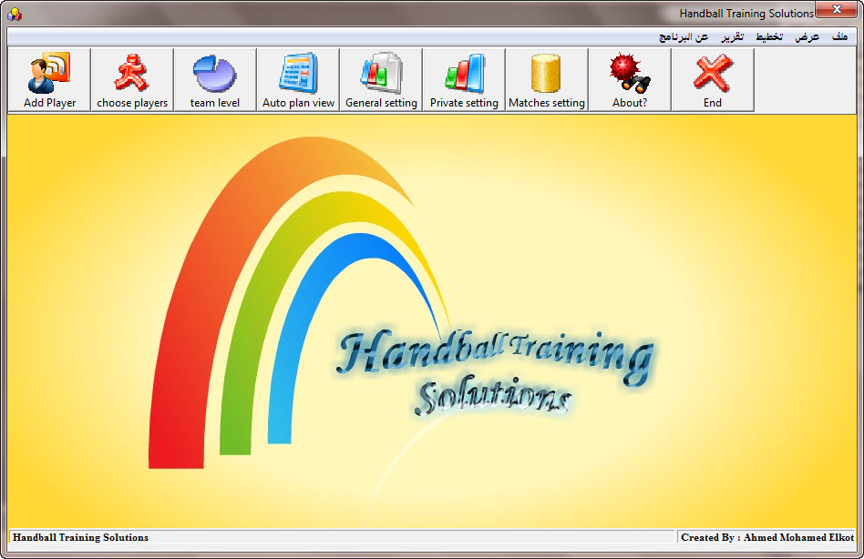

Fig.1: Main window of the system Handball Training Solutions
The expert system is designed for ease of time and effort by the trainer in the measurement and planning of the training program, which may take along-time in planning for coach to another, on the other hand, to develop a scientific basis of objective and codified scientific methods of athletic training Which is overlooked by some non-trained professionals who are not graduates of Physical Education, and there are steps that must be followed by the coach to prepare the planning period (under discussion) as follows:
1. Recording the names of the players window
This window is used to record the data belonging to the players as a team and the sports season to be planned, these data are kept in sql Database until they are called if necessary, and the following figure illustrates this window.
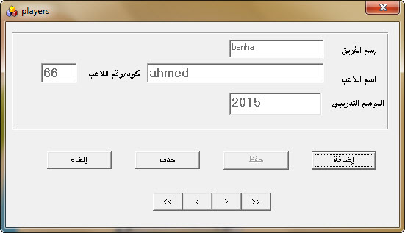

Fig.2: Registration for team names window
2. Choose tested players Window
The coach calls this window figure (3) to identify the players who would be subject to measurement or test before the planning process
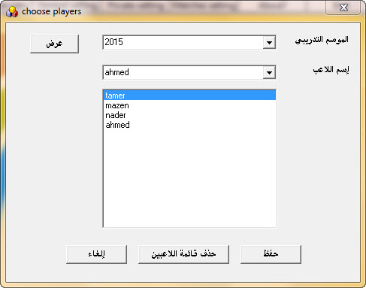

Fig.3: Window choose tested players

3. Recording the results of physical and skill tests window
The researcher to choose the number (13) test express own physical attributes Special handball players and some of the skills tests, where handball players undergo these tests before the planning process, so that the coach to identify a level that begins to him in planning for team ,Where the expert system to apply some of the knowledge and ideas about the results of these tests to get real values (standardized scores) can be taken into account And that reflect the true level of each player or team as a whole physically and Skillful, the following figure shows the registration window for the results of physical and skill tests for players

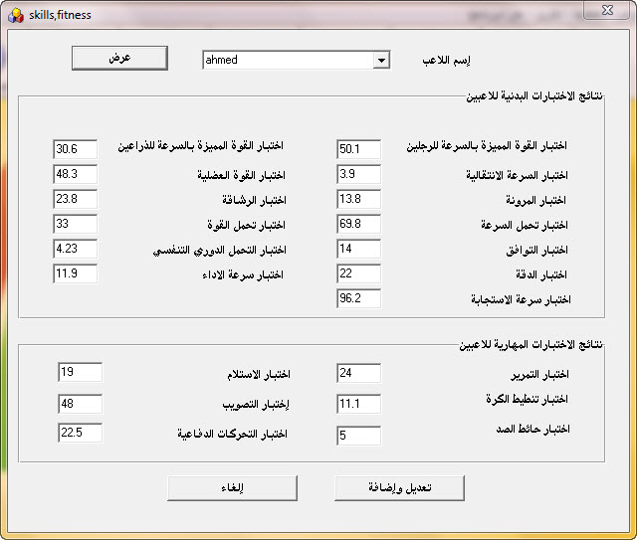

Fig.4: Recording the results of physical and skill tests window
4. Display team level in the physical and skill test
Clicking on this matter based expert system displays a report on the team for the physical and skill tests in the form of percentages (standard degrees C) from which recognize the level of the team, the following figure illustrates this
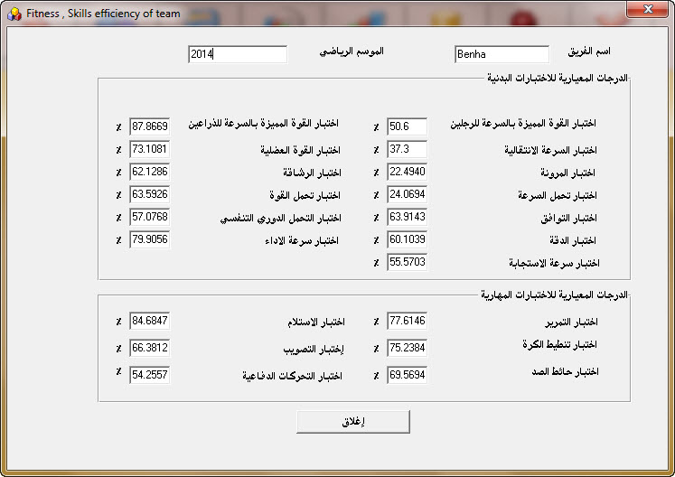

Fig.5: standard degrees to the level of the team physically and skillful

5. Rationing times in different modules of different physical load
Call this window of expert system asks the user system (trainer) for Time Deposit, which can be borne by the team's performance on the playground (physical / skillful / tactical), the coach supposed to set up this training module And applied to the players and calculate time to register in this window where the expert system based on knowledge and ideas inside width (9) times, in different training units within the physical load of medium and high intensity and maximum weeks, and figure (6) shows that.

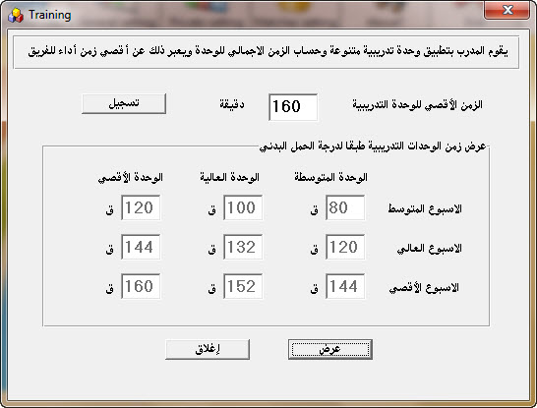

Fig.6: Times in different modules of different physical load

6. Determine the weekly training modules and the degree of physical load
The coach in this window by choosing modules each week, as well as the degree of physical load, whether 1: 1 or 1: 2 or 1: 3 figure (7)
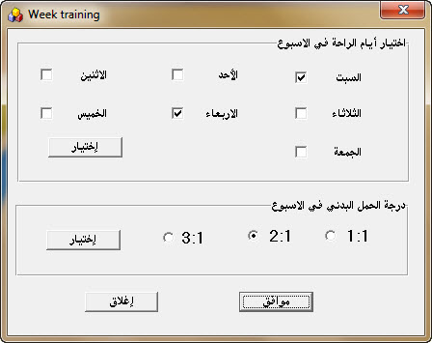

Fig.7: Identify training modules and the degree of physical load
7. Display times of training weeks of different physical load
The expert system after choosing the training days and the degree of load width times weekly training modules different medium and high physical load and maximum in both the medium and high intensity training and maximum weeks As well as the total time for the week, taking into account the degree of load and rest days, the following figures (8), (9), (10) describes the times, in different modules within the physical load week with medium and high load and maximum
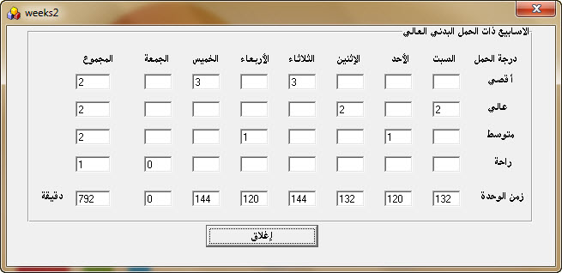
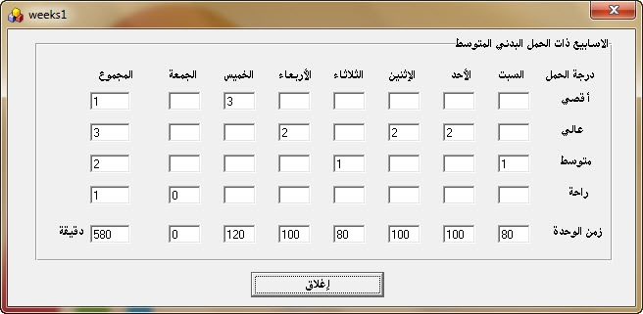

Fig.8: Times of training modules within the average week Fig.9: Times of training modules within the higher week

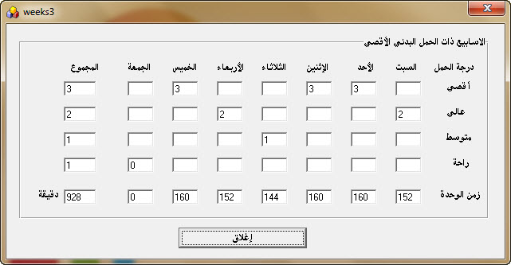

Fig.10: Times of training modules within the maximum week
8. Putting training aim for training units
for the system taking into account the contribution of physical attributes that participate in the performance variables in handball ratios we had to put the objectives of the training units in mind, especially during the setup phase, so the researcher creates a window of the figure (11) Containing the training period for this stage and inside it the training doses to enable the coach to choose the skillful training target, which the system based on the knowledge and information to look for physical attributes That share this aim, which turns into percentages taken from your physical preparation rate per unit basis and thus turned into a training minutes to serve the physical attributes required to develop performance skills
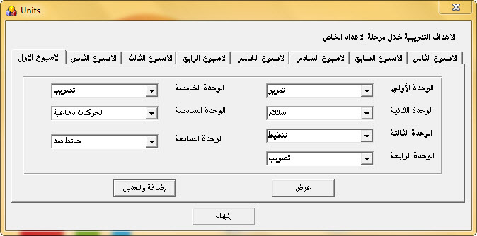

fig.11: training aim for training units
9. Automated planning
The expert system based on knowledge and ideas inside the former regime and the information incorporated layout view of the period setting to three periods (public / private / pre-games) automatically without the intervention of the coach in percentages and times and degrees of load account.
Where the researcher feeding system with the number and training periods typical for both of the numbers public and private period and pre-games, as the system takes into account the difference in rates and times of physical and skill and tactical preparation based on the different position in three periods (public / private / pre-games) , As the patron arrange the order development of physical attributes during preparation period based on the order of development, according to scientific foundations for athletic training, also takes into account the contribution of physical attributes which engages in developing performance skills of the players variables during the setup period ratios Based on the table (1) For example, when the aim of the training module will be developed shots by Jump the system automatically into account the contribution of physical attributes that participate in the performance of the skill of the shots by Jump ratios So that development be in the direction parallel to the physical and Skillful and lack of development of the qualities with different skills opposed, and the window with a comprehensive plan for the three periods of preparing ,the following figure shows planning general preparation period.
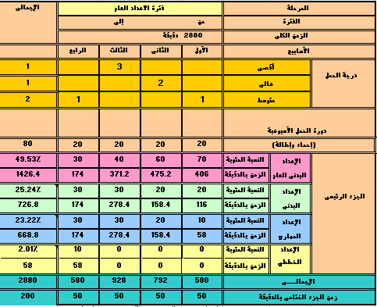

Fig.11: Schematic form of general preparation phase
10. Planning through Coach
When the trainer wants planning through (flexible plan) or modification in the system, the system planning expert calls the windows each window shaped period (10), where the trainer manually through each period to choose the number of weeks that the team wants to train them and to choose the degree of load As well as put the percentages for both physical and skill and tactical per week where the numbers take into account how different these ratios at every period and every week training unit and thus get the coach to plan a comprehensive training period, which have been selected in the proportions and times and the degree of physical load.
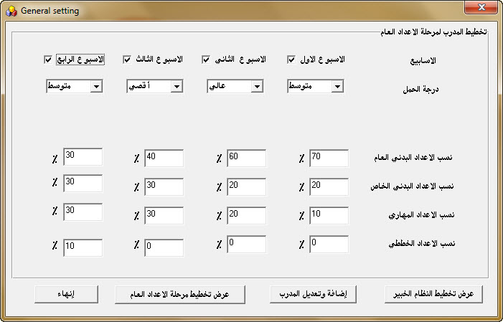

Fig.12: Coach planning to general preparation period window

11. Report
When click on this figure (13) is an expert system displays a drop-down list contains a presentation training weeks for each period separately reports contain the degree of load and percentages and time in minutes for both the physical and the skill and tactical within each module setup .

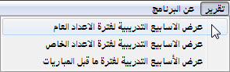

Fig.13: List report

12. Showing a training week in private preparing period
From the window of report can be obtained on the planning training weeks by expert system with load degrees ,percentage and time for each training units ,when we look at figure (14) Note the presence of training aim for each training module, which has been registered in window as shown in figure (11) When comparing the first unit aim of the training on Saturday and percentages in through both the physical private and skillful prepare And by reference to the table (1) note that the expert system takes into account the physical capacity that contribute to the development of performance skills development link variables (target module) which indicates that the system is intelligent and applied for athletic training bases in handball.

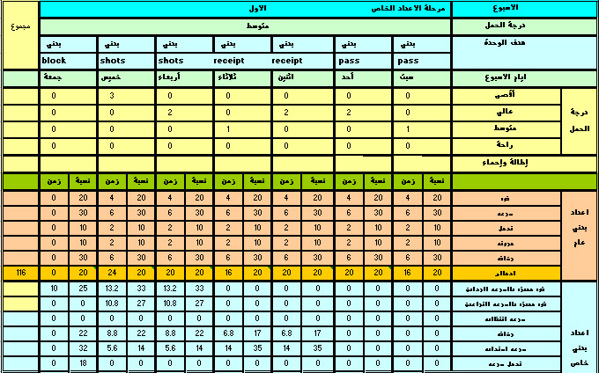

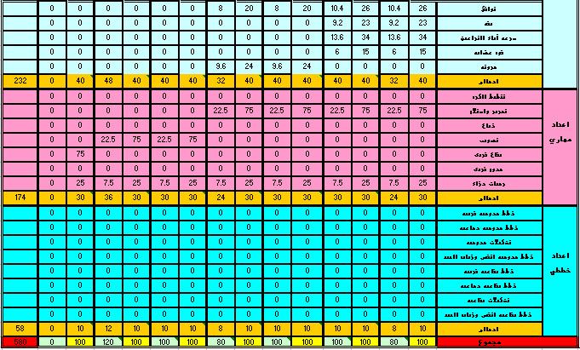

Fig.14: report of training week in private preparing period
Scientific Transactions of the expert system
Validity
The researcher using validity of the content or substance of the system expert ratified by ensuring that the expert system contains three phases (prepare public / private / pre-games) and the degree of load and prepare for physical , skill , tactical preparation , the number of training days and the formation of load cycle weekly .
The researcher using the validity of arbitrators for expert system by offering expert system of two arbitrators in the field, where they pointed out that this system is intelligent and applied athletic training grounds and sensitive to differing rates and times of physical skill and tactical preparation Depending on the different positions within the three periods, and pointed out that the main stake upon which this system is time so as to control the degree of training load from the point of considering research But pointed out that it is possible to have a different time, but in periods of control interfaces comfort is used as index for high and low degree of load in the training modules.
Stability
The researcher to find a reliability coefficient of expert system where the researcher to conduct physical tests on the number (11) for the player of the Benha Club Team Sports as follows:
• Stability for the coefficient of standard grades of the results of physical and skill tests.
The researcher enters the results of physical and skill tests (for the research sample) expert system for the standardized scores (v) the results of the physical and skill tests and re-enter it also to get a standard scores again And to find the correlation coefficient, where it came to value (0.1) as table (2) which indicates the stability of the system smart to get a standard grades of the results of physical and skill tests.
Table (2)
Reliability coefficient of an expert system for the standardized scores (v) the results of the physical and skill tests
variables |  | First test % | Second test % | Person correlation
physical | Distinctive strengths of legs | 62.6 | 62.6 | 1.0
 | Distinctive strengths of arms | 46.4 | 46.4
 | Transition Speed | 53.0 | 53.0
 | Muscle power | 39.6 | 39.6
 | Flexibility | 48.1 | 48.1
 | Fitness | 55.3 | 55.3
 | endurance of Speed | 41.9 | 41.9
 | endurance of Strength | 60.4 | 60.4
 | Compatibility | 60.4 | 60.4
 | Cardio respiratory endurance | 57.7 | 57.7
 | Accuracy | 40.7 | 40.7
 | Performance speed | 58.4 | 58.4
 | The speed of response | 34.5 | 34.5
skillful | pass | 45.9 | 45.9
 | The receipt | 42.7 | 42.7
 | Dribble | 35.9 | 35.9
 | shotting | 64.4 | 64.4
 | Block shot | 48.7 | 48.7
 | Defensive movement | 57.5 | 57.5
*Stability coefficient of the expert system at times, in different modules of different physical load
The researcher finding stability coefficient of times, in different modules physical load, where the introduction of a maximum time for the unit training for the first time (160 minutes) and got the times of training modules and then entered it again to get the actual time again The correlation coefficient between the entry time for the first time and the second (0.1) as table (3) which shows the reliability expert in getting the times of different modules physical load.
Table (3)
Reliability coefficient for the expert system to the times of
Different physical load modules
Training weeks | load | First time | Second time | Person correlation
Average weeks | Average | 80 minute | 80 minute | 1.0
 | High | 100 minute | 100 minute
 | Max | 120 minute | 120 minute
High weeks | Average | 120 minute | 120 minute
 | High | 132 minute | 132 minute
 | Max | 144 minute | 144 minute
Max weeks | Average | 144 minute | 144 minute
 | High | 152 minute | 152 minute
 | Max | 160 minute | 160 minute
Objectivity
The researcher introduced the system for five handball coaches and they brought some physical and skill tests data was access to standardized scores for the players and for the team in these variables, and they have the help of this system has been in planning their access to comprehensive planning for the period of training They see, has been downloaded analyze and discuss the results of the planning process and that this system is intelligent and simulates the human mind for planning capabilities in athletic training.
Statistical treatments
- Percentage -standard deviation
- Means - Standard degree
- Standard degree (t) - Pearson correlation coefficient

Conclusions
1. Expert System is intelligent system from one of the applications of artificial intelligence and it have validity, stability and objectivity and knowledge of the foundations of good planning for the athletic training in handball.
2. Through expert system obtain the standard grades to guide the trainer during the planning as well as the results of the tests for each player and the different discrimination.
3. Expert System is an intelligent system based on information and ideas to take into account the contribution of physical attributes that share some of the performance skills of the players in the training modules variables ratios.
4. Expert system taking into accounts the difference in percentages and times of the various modules within the physical load of medium and high intensity and maximum weeks.
5. When using an expert system for layout automatically without the intervention of the coach is to observe the different rates and times of both the physical and the skill and tactical preparation according to each period of preparation, whether (public prepare / private / pre-games).
6. You can get on the statistical report for measurements of physical and technical skills as well as standard grades for each player on the unit through various training seasons.
7. When using an expert system for layout automatically selects the training amount for each period of public and private numbers and pre measurements of the players.
8. Visible sketch to illustrate the differences between both the physical and the skill and tactical preparation during each period of three numbers when planning automatically and manually.

Recommendations

1. The trainers in the field of handball must be guided by in one of the applications of artificial intelligence (expert system) which is based on the knowledge in the training of handball teams.
2. The need to promote the use of this system for trainers by the Egyptian Handball Federation to assist them in the application of the scientific basis for the planning of training in handball.
3. The need to put this intelligent system in mind when work and organize training courses for trainers for promotion from one category to another through a committee of trainers in Egyptian Handball Federation.
4. The need for studies and other scientific research mimic human intelligence, which serves the area of training as planning individual training for goalkeeper automatically in handball.
5. Further research in the field of artificial intelligence applications, which contributes to identify the physical condition of the players, during handball games.

"References"
1-Ashraf Fathi Abd El-Mohsen (2002): Determination of physical and physiological levels as a function of the development to performance skills of the handball players, Ph.D, Faculty of Physical Education for Boys, Helwan University, Cairo,p:2(in Arabic).
2-Mohammad Hassan Allawi (1994): The Science of sports training, i 3, Dar knowledge, Cairo,p:40(in Arabic).
3- Ibrahim Mahmoud Gharib (1996): A program for the development of some of the physical skills and qualities of an emerging handball under 17 years old, Ph.D., Faculty of Physical Education for Boys, Zagazig University,p:2,3(in Arabic).
4-Mohammed Abd allah Mohammed (2013): The impact of the development of physical attributes in the light of their contribution rates at the level of performance skills and some physiological variables of handball players, Ph.D., Faculty of Physical Education for Boys, Benha University,p:55(in Arabic).
5-Adel Abd El-Basir (1990): athletic training, theory and practice, Peace Press, Alexandria,p:217(in Arabic).
6-Hillman, sonald (1995): Artificial intelligence human factors, 22, 27, febrewary, p: 12,205(in English).
7-Hu,D(1995).”Expert systems for software engineers and managers” new york, champ man &Hall,p:22(in English).
8-Brownston, L,R,Farrel&N-Nastin(1995):”Programming expert system in ops-an introduction to rule- based programming reading” ,MA : assison nesely,p:101(in English).
9- Minusie, Mark (1995): putting expert system on their place ,Al expart5,January ,p:78(in English).
10-Mohamed Fahmy tolba, al-sayed Nasr al-Din (1994): the computer and artificial intelligence, a collection of books Delta, Cairo , p:168(in Arabic).
11- Ponlitz,L (1995): A modern method of computer aided collection and evaluation of training and competition data for endurance ,event,germany,p:314(in English).
12- Abu-Elela Ahmed Abd el-Fattah (1992): training swim upper levels, Dar Al Arab Thought, Cairo,p:306(in Arabic).
13-Emad Elddin Abbas Abu Zaid (2005): Planning the scientific foundations to build and prepare the team in team sports "theories and applications," Knowledge facility in Alexandria, the first edition. , p: 31(in Arabic).

********************

